# Board Exploration

Here is some board exploration (standard cubes), which is done with simulated annealing algorithm.

## Board Containing the Least Words

The following board contains exactly no word (without the four letters long limitation).

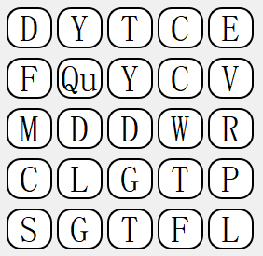

## The Longest Word

The following board contains a 15 letters long word “indetermination”.

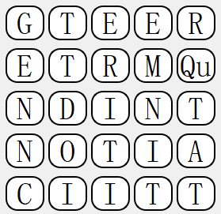

## Highest-Scoring Board

The following board scores 4700 points.

